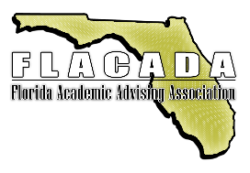

Copy this note into an email to your manager to prove the value of your attendance at FLACADA 2021.
[Date]

Dear [Manager/Supervisor’s Name]:

I am interested in attending the 2021 FLACADA Annual Conference on May 13th (pre-conference) to May 14th at Embry Riddle Aeronautical University, Daytona Beach, Florida. This one day conference covers a wealth of professional development opportunities.

Attending the conference will enable me to acquire in‐depth information on the latest proven strategies for [insert your initiative here], validate the current direction of our department’s projects, and recognize and avoid common pitfalls of implementation and operation.

I plan to attend several sessions providing training in areas of [fill in topic areas] that could be put to use immediately with [project(s) you are working on].

FLACADA 2021 will also provide many opportunities to confer with peers and experts in sessions and learn best practices from around the state. I will be happy to share these cost‐ and time‐saving ideas with my colleagues at [department or institution name] when I return.

I am seeking approval for the registration fee, plus travel expenses. The detailed cost breakdown is listed below:
Airfare: $
Transportation: $
Hotel: $
Meals: $
Registration Fee: $
Total Cost: $

Please accept this proposal to attend as I’m confident in the significant return will outweigh the time away from the office. Thank you for considering my request.

Sincerely,
<insert-your-name-here>

